Multiple Condition Coverage (MCC)

What is Multiple Condition Coverage (MCC)
# Source: Chatgpt (GPT-5-Standard) at [8/16/2025]
Multiple Condition Coverage (MCC) is a white-box testing technique where all possible combinations of individual conditions within a decision are tested at least once.
It is the most thorough extension of condition testing because instead of just making each condition True and False at some point, MCC requires testing every possible combination of conditions.

🔍 Example 1:
# Source: Chatgpt (GPT-5-Standard) at [8/16/2025]
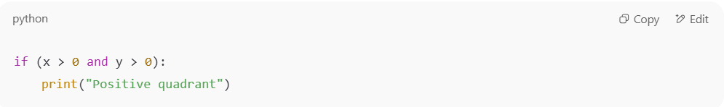
if (x > 0 and y > 0):
print("Positive quadrant")

- Conditions:
  - x > 0
  - y > 0
👉 Possible combinations:
- x > 0 = True, y > 0 = True
- x > 0 = True, y > 0 = False
- x > 0 = False, y > 0 = True
- x > 0 = False, y > 0 = False
✅ To achieve MCC, we must test all 4 combinations.

🔍 Example 2 (with OR):
# Source: Chatgpt (GPT-5-Standard) at [8/16/2025]
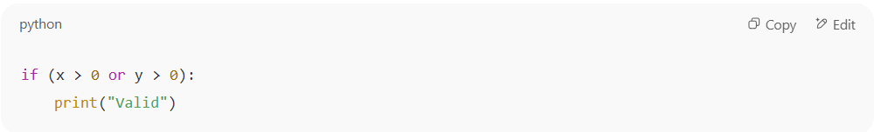
if (x > 0 or y > 0):
print("Valid")

- Conditions:
  - x > 0
  - y > 0
👉 Possible combinations:
- x > 0 = True, y > 0 = True
- x > 0 = True, y > 0 = False
- x > 0 = False, y > 0 = True
- x > 0 = False, y > 0 = False
✅ MCC requires all 4 cases.

📊 Formula for Multiple Condition Coverage:
# Source: Chatgpt (GPT-5-Standard) at [8/16/2025]
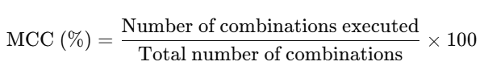
MCC (%)=Number of combinations executedTotal number of combinations×100\text{MCC (\%)} = \frac{\text{Number of combinations executed}}{\text{Total number of combinations}} \times 100

✅ Why is it stronger?
# Source: Chatgpt (GPT-5-Standard) at [8/16/2025]
- Statement Coverage: Every statement runs at least once.
- Decision Coverage: Every decision outcome (True/False) is tested.
- Condition Coverage: Every atomic condition is tested as True and False.
- Multiple Condition Coverage: Every possible combination of condition outcomes is tested.
👉 MCC gives maximum confidence in testing logical decisions.

⚖️ Advantages:
# Source: Chatgpt (GPT-5-Standard) at [8/16/2025]
- Catches subtle logical errors in complex decisions.
- Provides highest level of confidence in decision testing.

⚠️ Limitations:
# Source: Chatgpt (GPT-5-Standard) at [8/16/2025]
- Combinatorial explosion: If a decision has n conditions, there are 2^n combinations.
  - For example: 5 conditions → 32 test cases needed.
- Not always practical for large systems.

✅ In short:
Multiple Condition Coverage = Test all possible True/False combinations of conditions inside a decision.
It’s the strongest but most expensive form of decision-based white-box testing.

